



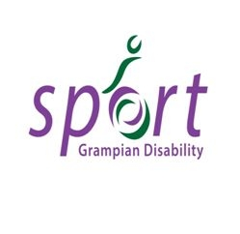

**Disability Sport**

Summer  
Programme

2016

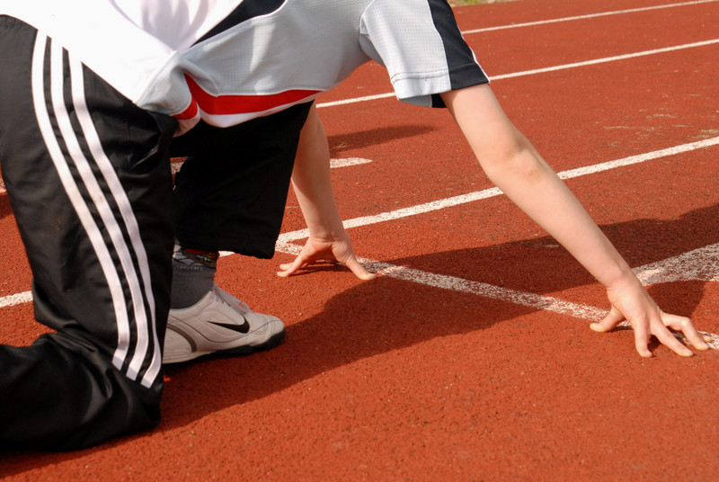

Serving Aberdeenshire from mountain to sea - the very best of Scotland

**If you have any queries please contact Caitlin Dudley, Disability Sports Officer on** [**caitlin.dudley@aberdeenshire.gov.uk**](mailto:caitlin.dudley@aberdeenshire.gov.uk) **or 07768 051479. Information also available in audio format**

**For more information on disability sport opportunities visit:**

[www.aberdeenshire.gov.uk/recreation/disabilitysport/index.asp](http://www.aberdeenshire.gov.uk/recreation/disabilitysport/index.asp)

<http://grampiandisabilitysport.org.uk/gds/>

[www.facebook.com/grampiandisabilitysport](http://www.facebook.com/grampiandisabilitysport)

[www.aberdeenshire.gov.uk/facebook](http://www.aberdeenshire.gov.uk/facebook)

ACTIVITIES

Skateboarding

Participants will be coached in the basics of skateboarding in an indoor skatepark brand new to Transition in 2015.

Climbing Wall

Participants will be supported by instructors to experience an introduction to the heights of indoor climbing

*Please note for activities at Transition Extreme - the centre will be busier than usual over this holiday period and the noisy environment may not be suitable for some potential attendees who may be adversely affected by loud noises or large groups of people.  Please see *** below.*

Ten Pin Bowling

A Ten Pin Bowling session at the Garioch Indoor Bowling Centre, Inverurie.

Ice Skating Sessions

Participants will have the use of sledges if less able to self-propel on ice. Participants must be accompanied on the ice by a parent/ carer if they require assistance.

Tubing Sessions

Participants can enjoy a thrilling ride down the dry ski slope on a large rubber ring. Tow available.

ASN Summer Camp at Aberdeen Sports Village including:

Trampolining

Sessions are fully accessible with a hoist, steps and sag bags available.

Indoor Athletics Sessions

A fun athletics session held in the purpose built athletics area at Aberdeen Sports Village. Participants will be introduced to run, jump and throw activities.

Boccia & Kurling

Participants will get the chance to play Boccia and Kurling through fun skills and drill sessions. Sessions are fully accessible with ramps available for participants who can’t throw independently.

Pool Fun

Participants can take part in fun pool games or swim at their leisure under the guidance of qualified aquatics teachers. Floor depth in the 25m pool will be raised to 1.2m & hoists will be available for use. Participants that are not confident swimmers, who are under 8yrs of age or who need physical support in the pool or changing area will need to be accompanied by an adult into the water. Please note the sessions will take place in a sectioned off area of the pool but members of the public will have access to the rest of the pool during the session.

Sensory Games

Explore your senses playing fun, active games using parachutes, the floater ball, textured equipment and shape-matching. Pupils with sensory impairments will be able to enjoy the ‘level playing field’ of these games.

Bounce Fun

Using a range of inflatable and sprung equipment including trampettes, springboards & the air track, people of all ages & abilities will have a blast whilst doing twists, turns, shapes & rolls!

Football & Touch Rugby

Adapted football and touch rugby warm ups and games designed to encourage team-working & co-ordination

Team Building

Solve problems, tackle challenges & complete obstacles as part of a team under the guidance of our coaches.

Racquet Sports

A mix of popular racquet sports including badminton, table tennis, short tennis & racketball.

Field Games

A whole host of outdoor active games played on the Indoor Pitch. May include rounders, ultimate Frisbee, tug of war, obstacles courses and many more.

Wacky Races

A Range of individual and team races with emphasis on fun & creativity.

*Please note participants are able to attend the ‘full’ half day camp or choose to just come for one or two activities. Parents/carers are invited to stay for the duration of camp. However, if they do not wish to stay, participants can be dropped off at the start of the camp and collected at the end if they are able to support themselves with limited supervision. Activities will be held in the same areas as the other summer camps where noise levels can be high.*

**For all activities**: Clothing: Children should come appropriately dressed for practical sessions.  
Refreshments: Please bring a bottle of water or non-fizzy drink and a snack if needed. If attending ASV half day camp on 11th August please bring a packed lunch.

Also available for Summer 2016 – **Disability Sailing Sessions** – Peterhead – Thursdays 7-9pm. For more information and to book a place please contact Angie Fraser, Aberdeenshire Sailing Trust, on 07812380834 or [angie@aberdeenshiresailing.org](mailto:angie@aberdeenshiresailing.org) Pre-booking essential.

Summer Programme 2016

|  |  |  |  |  |  |  |  |  |  |  |  |  |  |  |  |  |
| --- | --- | --- | --- | --- | --- | --- | --- | --- | --- | --- | --- | --- | --- | --- | --- | --- |
| **Date / Sport** | **Time** | | | | | | **Venue** | | | **Cost** | **Age** | **Tick (✓)** | | | | |
| **ASN Summer Camp at Aberdeen Sports Village** | | | | | | | | | | | | | | | | |
| **Thursday 21st July** | | | | | | | | | | | | | | | | |
| Trampoline | 09.45 – 10.45 | | | | | | Aberdeen Sports Village | | | £4 | Mixed |  | | | | |
| Field Games | 11.00 – 12.00 | | | | | | Aberdeen Sports Village | | | £4 | Mixed |  | | | | |
| Athletics | 12.15 – 13.15 | | | | | | Aberdeen Sports Village | | | £4 | Mixed |  | | | | |
| Half Day Camp * | 09.45 – 13.15 | | | | | | Aberdeen Sports Village | | | £10 | Mixed |  | | | | |
| **Friday 22nd July** | | | | | | | | | | | | | | | | |
| Pool Fun | 09.00 – 10.00 | | | | | | Aberdeen Sports Village | | | £4 | Mixed |  | | | | |
| Football & Touch Rugby | 10.30 – 11.30 | | | | | | Aberdeen Sports Village | | | £4 | Mixed |  | | | | |
| Racquet Sports | 11.45 – 12.45 | | | | | | Aberdeen Sports Village | | | £4 | Mixed |  | | | | |
| Half Day Camp * | 09.00 – 12.45 | | | | | | Aberdeen Sports Village | | | £10 | Mixed |  | | | | |
| **Monday 25th July** | | | | | | | | | | | | | | | | |
| Bounce Fun | 12.30 – 13.30 | | | | | | Aberdeen Sports Village | | | £4 | Mixed |  | | | | |
| Sensory Games | 13.45 – 14.45 | | | | | | Aberdeen Sports Village | | | £4 | Mixed |  | | | | |
| Team Building | 15.00 – 16.00 | | | | | | Aberdeen Sports Village | | | £4 | Mixed |  | | | | |
| Half Day Camp * | 12.30 – 16.00 | | | | | | Aberdeen Sports Village | | | £10 | Mixed |  | | | | |
| **Tuesday 26th July** | | | | | | | | | | | | | | | | |
| Wacky Races | 13.30 – 14.30 | | | | | | Aberdeen Sports Village | | | £4 | Mixed |  | | | | |
| Field Games | 14.45 – 15.45 | | | | | | Aberdeen Sports Village | | | £4 | Mixed |  | | | | |
| Trampoline | 16.00 – 17.00 | | | | | | Aberdeen Sports Village | | | £4 | Mixed |  | | | | |
| Half Day Camp * | 13.30 – 17.00 | | | | | | Aberdeen Sports Village | | | £10 | Mixed |  | | | | |
| **Wednesday 10th August** | | | | | | | | | | | | | | | | |
| Trampoline | 09.30 – 10.30 | | | | | | Aberdeen Sports Village | | | £4 | Mixed |  | | | | |
| Bounce Fun | 10.45 – 11.45 | | | | | | Aberdeen Sports Village | | | £4 | Mixed |  | | | | |
| Racquet Sports | 12.00 – 13.00 | | | | | | Aberdeen Sports Village | | | £4 | Mixed |  | | | | |
| Half Day Camp * | 09.30 – 13.00 | | | | | | Aberdeen Sports Village | | | £10 | Mixed |  | | | | |
| **Thursday 11th August** | | | | | | | | | | | | | | | | |
| Boccia/Kurling | 11.30 – 12.30 | | | | | | Aberdeen Sports Village | | | £4 | Mixed |  | | | | |
| Athletics | 13.00 – 14.00 | | | | | | Aberdeen Sports Village | | | £4 | Mixed |  | | | | |
| Pool Fun | 14.30 – 15.30 | | | | | | Aberdeen Sports Village | | | £4 | Mixed |  | | | | |
| Half Day Camp * | 11.30 – 15.30 | | | | | | Aberdeen Sports Village | | | £10 | Mixed |  | | | | |
|  | | | | | | | | | | | | | | | | |
| **Other Activities (please** 🗸 **date(s) for the activities you wish to attend)** | | | | | | | | | | | | | | | | |
| **Monday 4th July** | | | |  | | **Monday 18th July** | |  | **Monday 1st August** | | | | |  | |  |
| Skateboarding** | 10.00 – 11.00 | | | | | | Transition Extreme | | | FREE*** | Ages 5-30 yrs | | | | | |
|  | | | | | | | | | | | | | | | | |
| **Wednesday 6th July** | | | |  | | **Wednesday 20th July** | |  | **Wednesday 3rd August** | | | | |  | |  |
| Climbing Wall** | 11.00 – 12.00 | | | | | | Transition Extreme | | | FREE*** | Ages 5-30 yrs | | | | | |
|  | | | | | | | | | | | | | | | | |
| **Friday 22nd July** | |  | | | **Wednesday 10th August** | | | | | | | | |  | |  |
| Ten Pin Bowling | 14.00 – 15.30 | | | | | | Garioch Indoor Bowling Centre | | | £4 | Mixed | | | | | |
|  | | | | | | | | | | | | | | | | |
| **Monday 25th July** | | |  | |  | | | | | | | | | | | |
| Ice Skating | 10.00 – 11.30 | | | | | | Ice Linx Arena | | | £4 | Mixed | | | | | |
|  | | | | | | | | | | | | | | | | |
| **Friday 29th July** | | |  | | **Tuesday 9th August** | | | | | | | |  | |  | |
| Tubing | 10.45 – 11.45 | | | | | | Alford Ski Centre | | | £4 | Mixed | | | | | |
| * *Including activities above*  *\*\* Due to the nature of the activities at Transition Extreme the number of pupils able to participate will be restricted. This may mean we have to restrict the number of sessions each participant attends depending on demand. We will be in touch if we cannot offer you all of the sessions you have applied for*.  *\*\*\* Activities at Transition Extreme are sponsored through the Community Activity Fund which was made possible through funding kindly donated to Transition Extreme by Sport Scotland and Subsea 7 in order to facilitate sports sessions for young people with additional support needs.  For any young people applicable for the Community Activity Fund who are unable to attend because of the busy Summer holiday environment Transition Extreme would be keen to offer the opportunity to attend through this scheme during term time. At this time the centre is far less busy and so we are able to establish a more comfortable environment for those attending.  Please get in touch with Caitlin if you would like more information on this.* | | | | | | | | | | | | | | | | |
| Please 🗸 session(s) you wish to book.  Cost for above activities: per person per session or half day.  Cheques made payable to 'Aberdeenshire Council' and returned with completed consent form to Caitlin Dudley, C/O Elaine Murray, Aberdeenshire Council, Active Aberdeenshire, Unit 19 Harlaw Industrial Estate, Harlaw Way, Inverurie, AB51 4SG.  Please note: you will be sent a receipt for your payment which will be confirmation of your place. If any of the activities become unavailable or if there are any changes you will be contacted on the details you provide overleaf. | | | | | | | | | | | | | | | | |

*Just a reminder that the following activities will still run in the Summer Holidays*

*Family Swimming Sessions, Beach Leisure Centre – Saturdays 5-6pm.  Contact BLC on 01224 655401*

*Multi-sports Club, Aberdeen Sports Village – Sundays 10.30am-12pm. Contact ASV on 01224 438900*

*Ten Pin Bowling, for 16 years and over, Garioch Indoor Bowling Club – Wednesdays 7.15-8.15pm. Contact GIBC on 01467 622622.*

CONSENT AND BOOKING FORM

Participant’s Name: ................................................................................. Age: .............

Address: ................................................................................................................................

............................................................................................... Postcode: ..............................

Name of School: (if applicable) .............................................................................................

Parent/Carer’s Name: ...........................................................................................................

Contact No. ............................................ Email: ...................................................................

Will a carer accompany the participant to the session? (Please circle) YES NO

If no, please give the name of someone we can contact during the time of the session in case of emergencies.

Name: .................................................................... Contact No. ..........................................

Please indicate any special medical needs e.g. Asthma, Epilepsy: .....................................

...............................................................................................................................................

Please indicate any additional support needs e.g. learning difficulties, wheelchair user:

..............................................................................................................................................

Please indicate any special communication needs e.g. sign language, Makaton: ............

...............................................................................................................................................

Please indicate if you require any special equipment e.g. boccia ramp, tubing tow, ice sledge etc.

…………………………………………………………………………………………………….

For participants with Down’s syndrome: has the participant been assessed for Atlantoaxial instability? (Please circle) YES NO

Do you consent to receiving first aid/medical treatment? (please circle) YES NO

Photography may be used during the sessions. Images will be used in publications and on our website to publicise our services or celebrate special events. These may also appear in our printed publications, on our website, intranet, social media ie facebook, twitter and on Plasma screens in various council offices. We may also send them to the news media.

Please tick this box if you **DO CONSENT to** your child being photographed and images used as indicated above **🞏**

Please tick this box if you **DO NOT** wish your child to be photographed and images used as indicated above **🞏**

Signature ........................................................................ Relationship .................................

Please include your email address if you would like to be added to our emailing list to be the first to hear about new clubs, events and training opportunities.

Email: ........................................................................................................................................

*The information given will be treated in confidence and held in accordance with the requirements of the Data Protection Act 1998.*

********

**Headquarters**

Aberdeenshire Council,

Woodhill House,

Westburn Road,

Aberdeen,

AB16 5GB

Visit: [www.aberdeenshire.gov.uk/recreation/disabilitysport/index.asp](http://www.aberdeenshire.gov.uk/recreation/disabilitysport/index.asp) or <http://grampiandisabilitysport.org.uk/gds/>

Twitter@aberdeenshire [twitter.com/SDS_sport](https://twitter.com/SDS_sport)

[www.facebook.com/grampiandisabilitysport](http://www.facebook.com/grampiandisabilitysport)

[www.aberdeenshire.gov.uk/facebook](http://www.aberdeenshire.gov.uk/facebook)

